TECHNICAL PROJECT LOGBOOK & PROGRESS REPORT

Student Details
Student Name: Brian kibet
Admission Number: BIT/20221/93373
Course/Class: Bachelor of Science in Information Technology
Unit Code: BIT4107
Unit Name: Mobile Application Development
Lecturer Name: Michael Nyoro

Project Details
Project Title: SETBOOK HUB
Selected Technologies: Kotlin
Jetpack Compose
Android Studio
SQLite
GitHub Link:

Week 1: Local Environment Setup
Figure 1.1: Installation of visual studio code
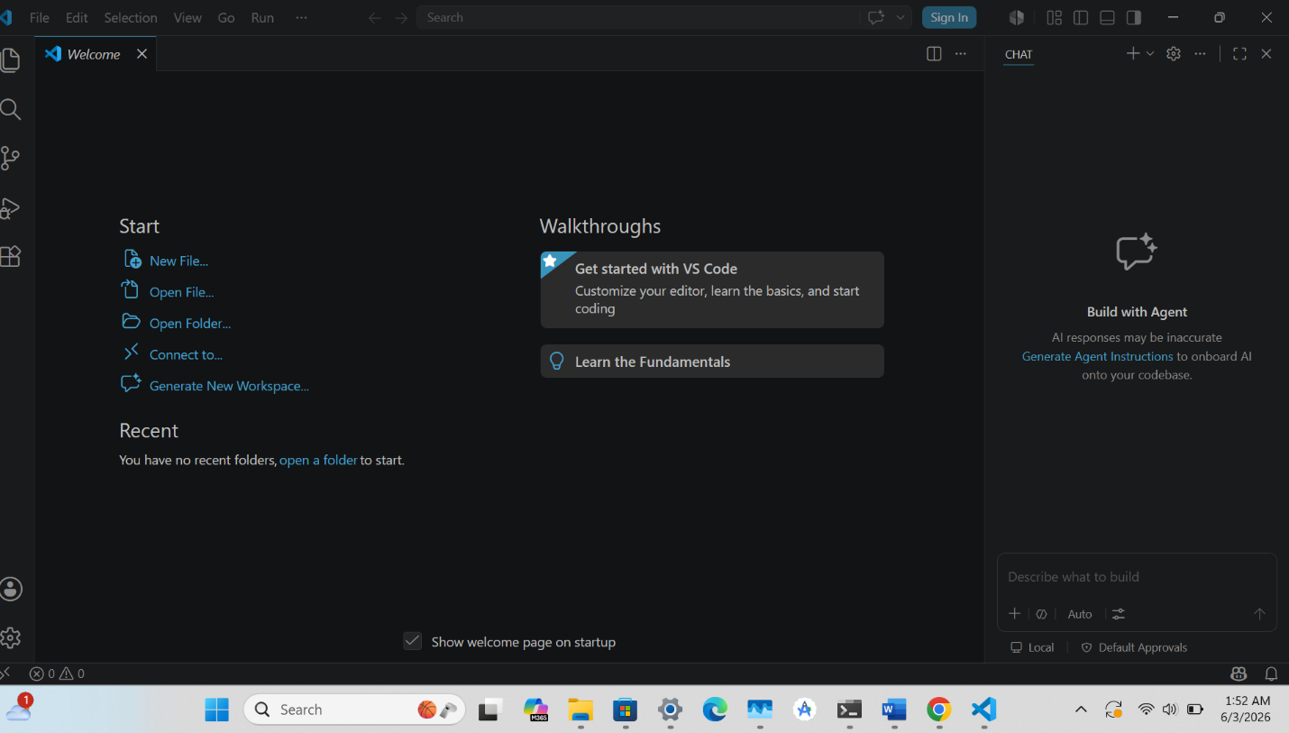

Week 2: Screen Display
Figure 2.1: Testing of "UserName"
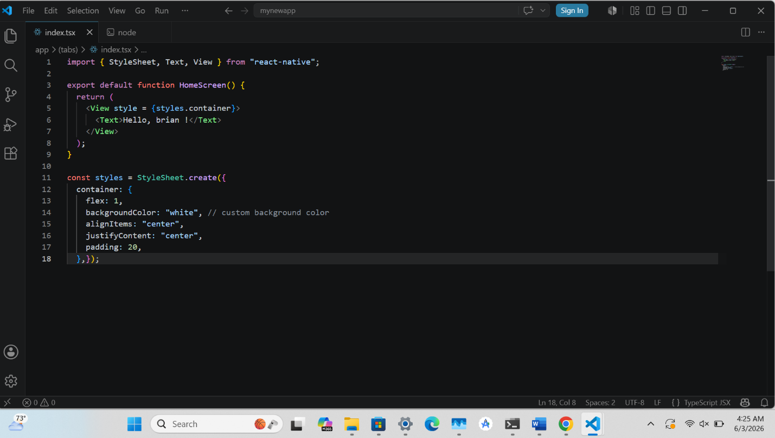

Week 3: Wireframes and GUI Design
Figure 3.1: Screen splash

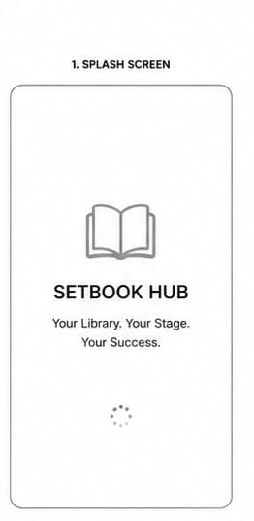

Figure 3.2: Home dashboard screen

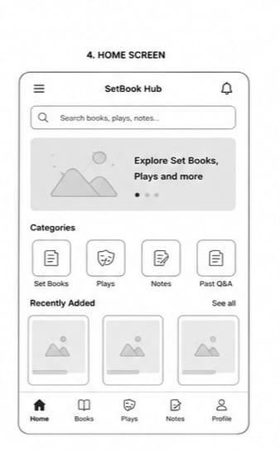

Figure 3.3: Place list

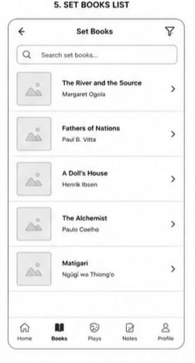

Figure 3.4: Place details

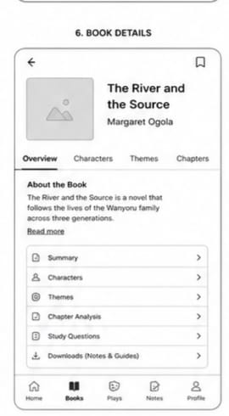

Figure 3.5: About screen

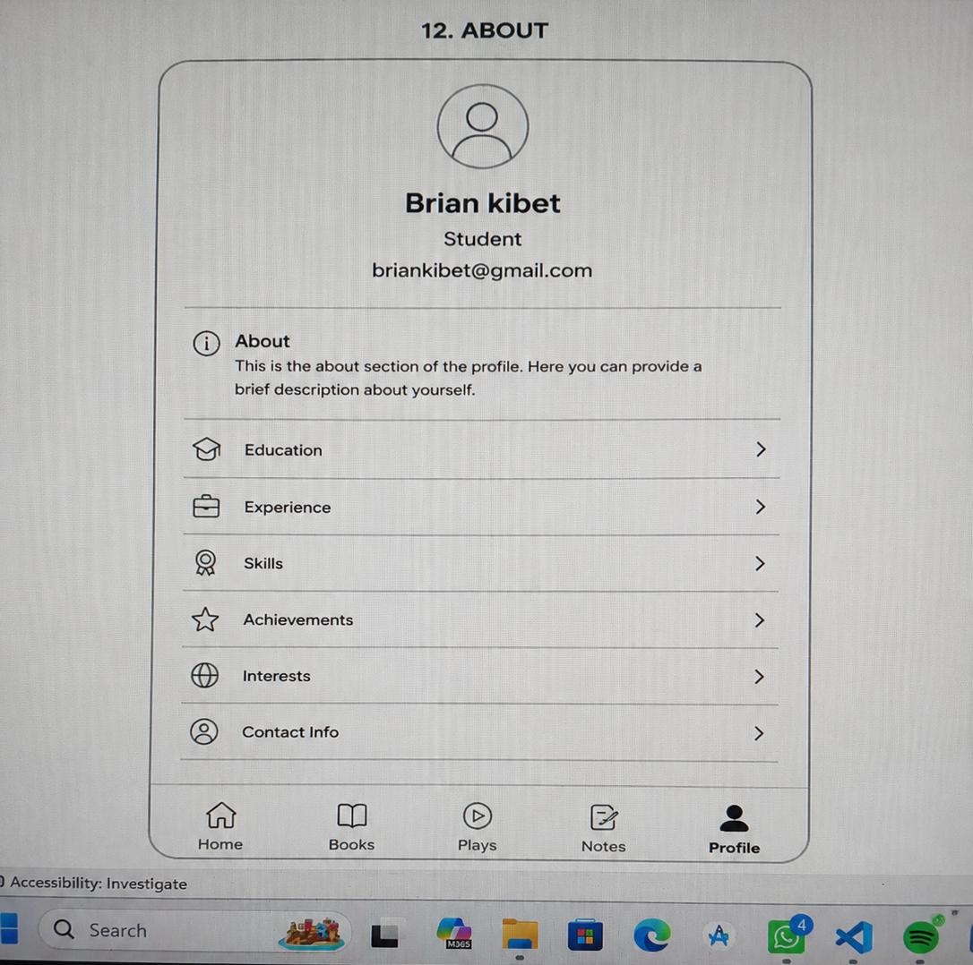

WEEK 4 USER INTERACTION
FIGURE 3.5 logins
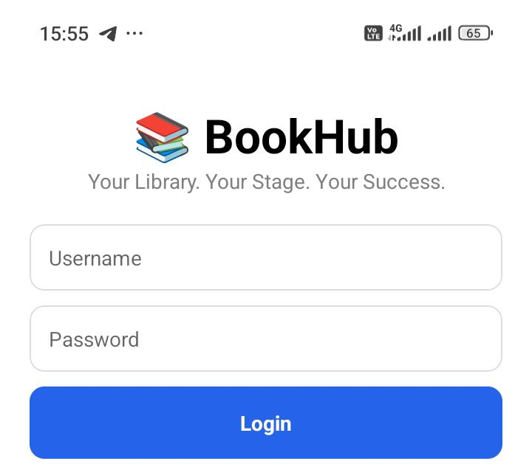
FIGURE3.6 REGISTRATION
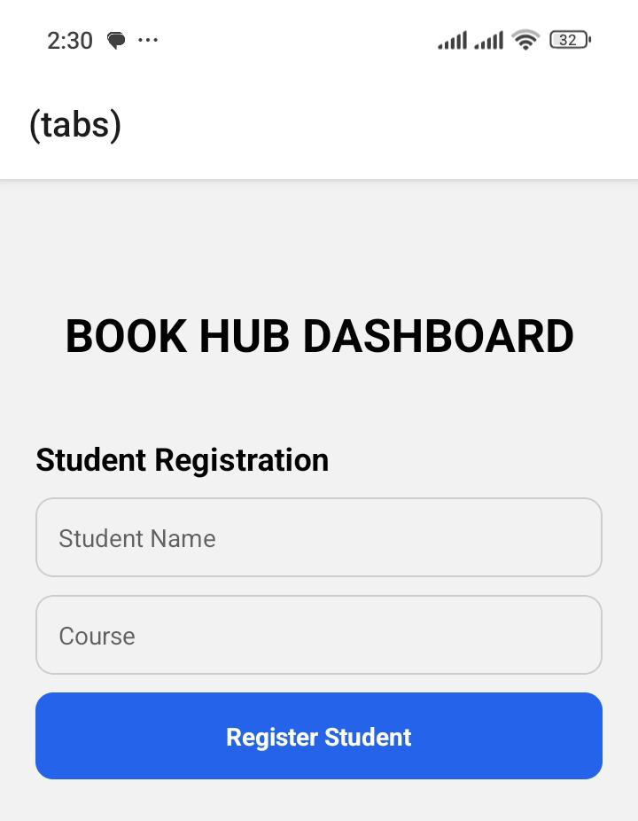
Week reflection: developed the BookHub login page and home screen using React Native. I designed the user interface, added login validation, and created categories such as Set Books, Plays, Notes, and Past Papers. This improved my skills in mobile app development and UI design.

WEEK 5 DATA MANAGEMENT
FIGURE 3.7
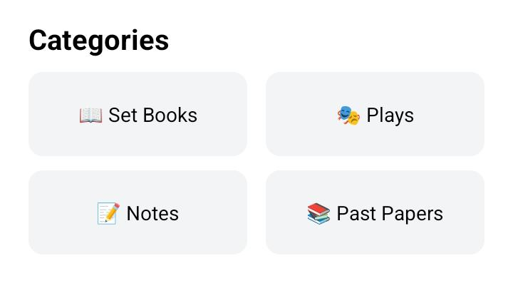

FIGURE 3.8 REGISTRED STUDENTS DATA
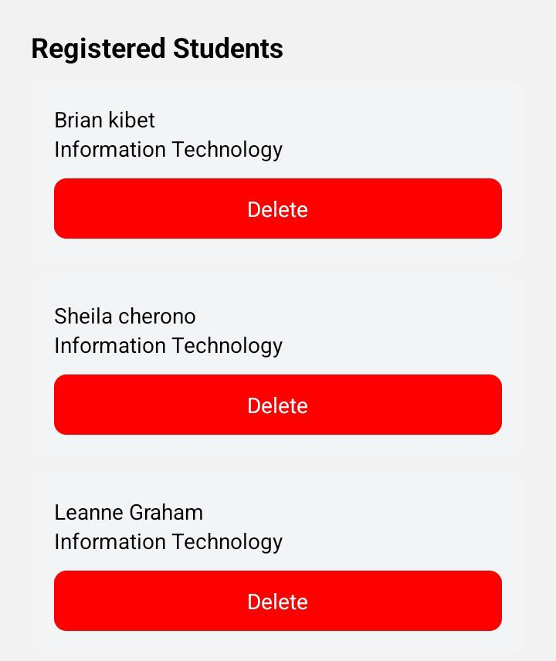
Week reflection: I enhanced the BookHub application by adding more features,Book Search, Profile, Reports, Favorites, and Downloads. I also improved the app layout and navigation, gaining more experience in React Native and project organization.

